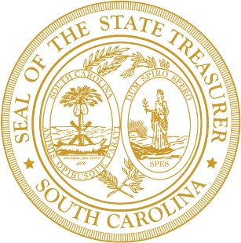
Board Members
HOWARD H. WRIGHT, JR. | Rock Hill
W. DONALD PENNINGTON | Simpsonville
F. JUSTIN STRICKLAND | Lexington
J. DANIEL WALTERS | Greenville
K. WAYNE WICKER | Myrtle Beach
J. BARRY HAM | Manning
BILLY D. BYRD, II | Hartsville
JENNY MICHAELS | Kansas City
THOMAS BOUCHETTE | Florence
CAROL W. ADDY | Georgetown

Chairman
THE HONORABLE CURTIS. M. LOFTIS, JR.
State Treasurer

Chairman Pro Tempore
HOWARD H. WRIGHT, JR.

SOUTH CAROLINA
STATE BOARD OF FINANCIAL INSTITUTIONS

February 4, 2026
10:00 A.M.
Conference Room 222
Wade Hampton Building, 2nd Floor
and
via virtual conferencing WebEx Login: Join meeting
Join by phone: 1-404-410-4537 / Access Code: 2345 373 4027 / Password: WPjjr7TA522

- Approval of the February 4, 2026 Proposed Agenda

- Approval of the December 3, 2025 Board Minutes

- Board Member Recusal or Conflicts of Interest with Items on this Agenda

- Committee Reports
4.1 Budget and Operations Committee

- Commissioner Reports
  - Consumer Finance Division
- Renewal Snapshot Report
- State Summary Report
- Monthly statistics
- Approved consumer licensees report
- Check cashing site visits

  - Banking Division
- Industry Engagement
- Education/Training
- Staffing
- Actions taken under delegated authority

- Executive Session
The Board will enter Executive Session to discuss information about and review requests by regulated entities and to receive legal advice as needed.

- Actions Following Executive Session

- Announcements
Reminder: Ethics Filing Due March 30th, 2026
Next scheduled meeting date: Wednesday, April 1, 2026

- Adjournment

NOTICE OF PUBLIC MEETING
This notice is given to meet the requirements of the S.C. Freedom of Information Act and the Americans with Disabilities Act. Furthermore, this facility is accessible to individuals with disabilities, and special accommodations will be provided if requested in advance. Please note that the Agenda is subject to change up to 24 hours prior to the scheduled meeting. For further information, contact Cameron Larkin at (803) 734-2699, bofi@sto.sc.gov , or visit the BOFI website at www.bofi.sc.gov .

